# **Introduction to Kubernetes control plane components**

We have seen before the components that are in control plane node,

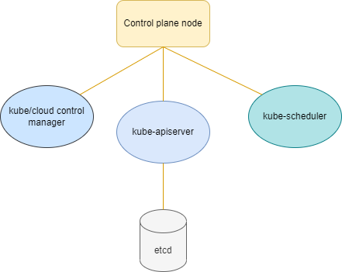

Whereas, kube-scheduler is divided into two major components

* filtering and
* scoring

Similarly kube-control manager has multiple controllers that perform a specific job:

* Node controller
* Job controller
* Endpoint Slice controller
* ServiceAccount controller and many more.

Note: If we are using cloud services to launch our cluster, we have a component called cloud-control manager which is similar to kube-control manager with few additional controllers such as:

* Node controller
* Route controller
* Service controller, etc.